**Create Git remote repository using Git account:** 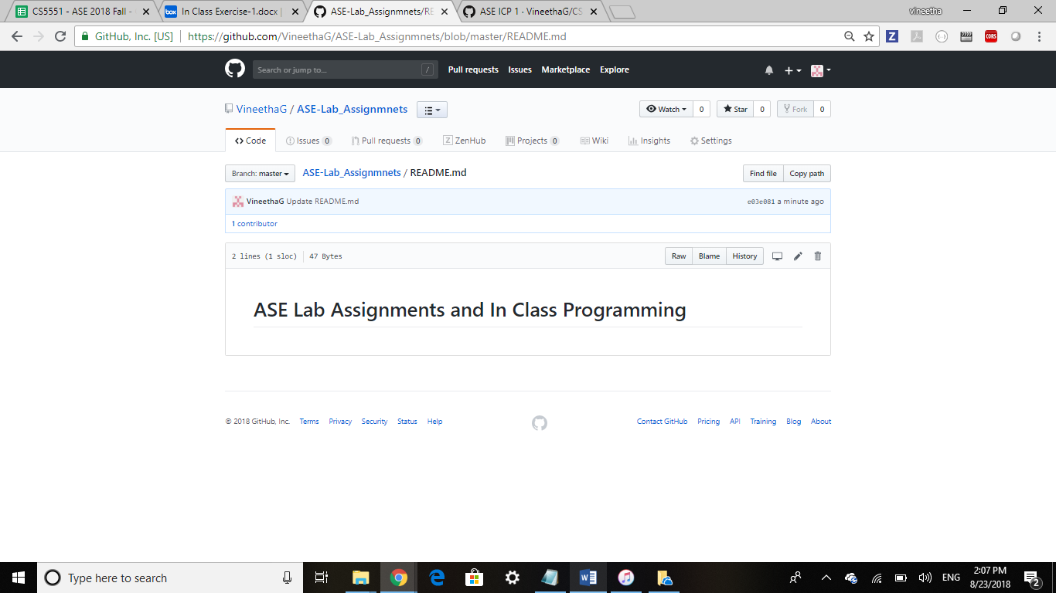

### Cloning Repository to local and creating folders:

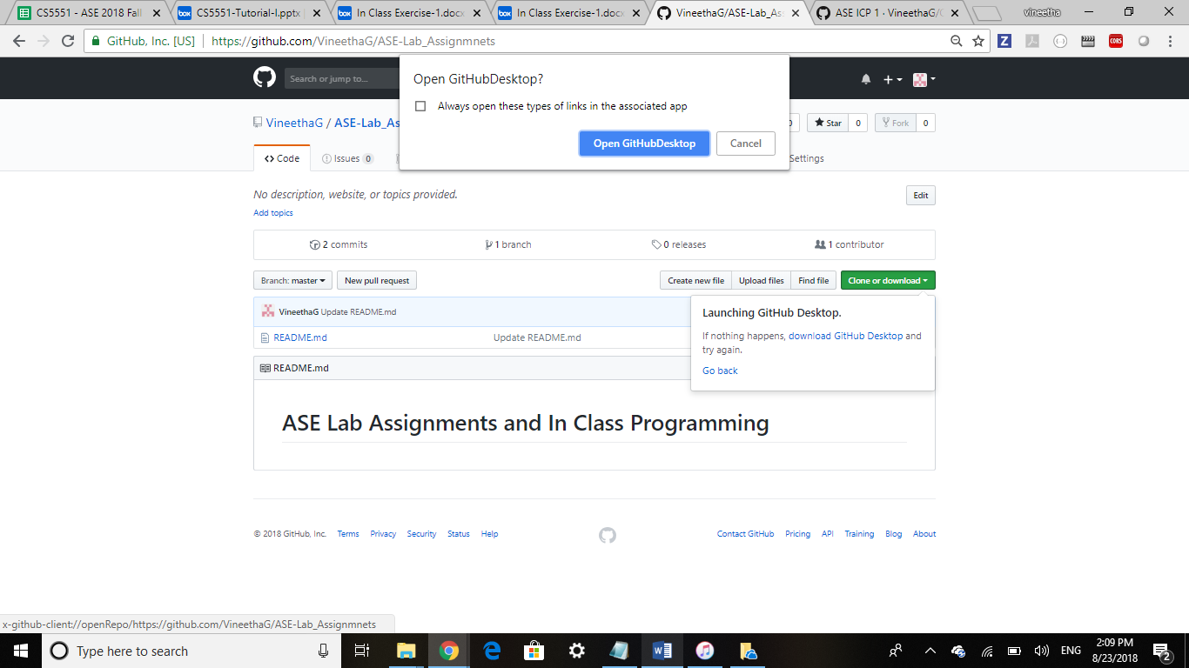

Cloned to local

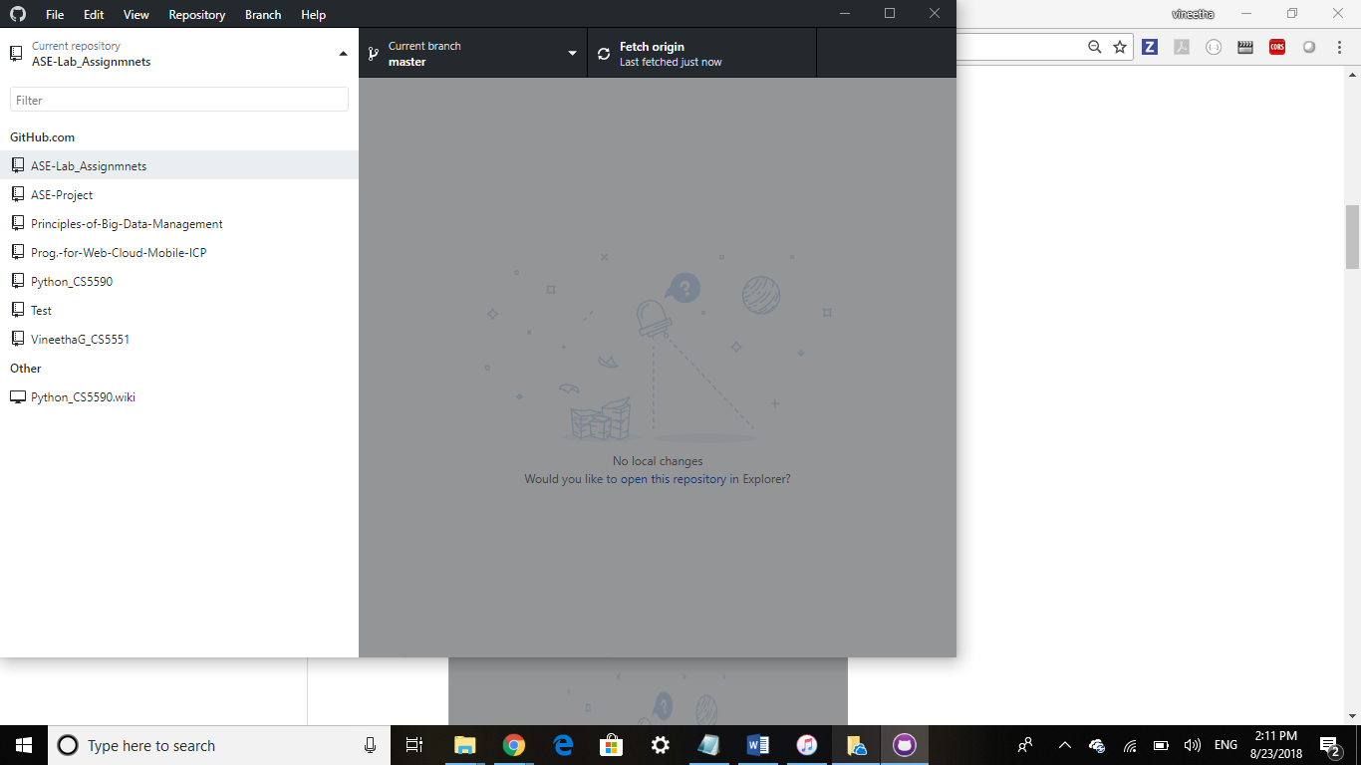

Created a sample file in local repository. Committed and pushed the changes to remote.

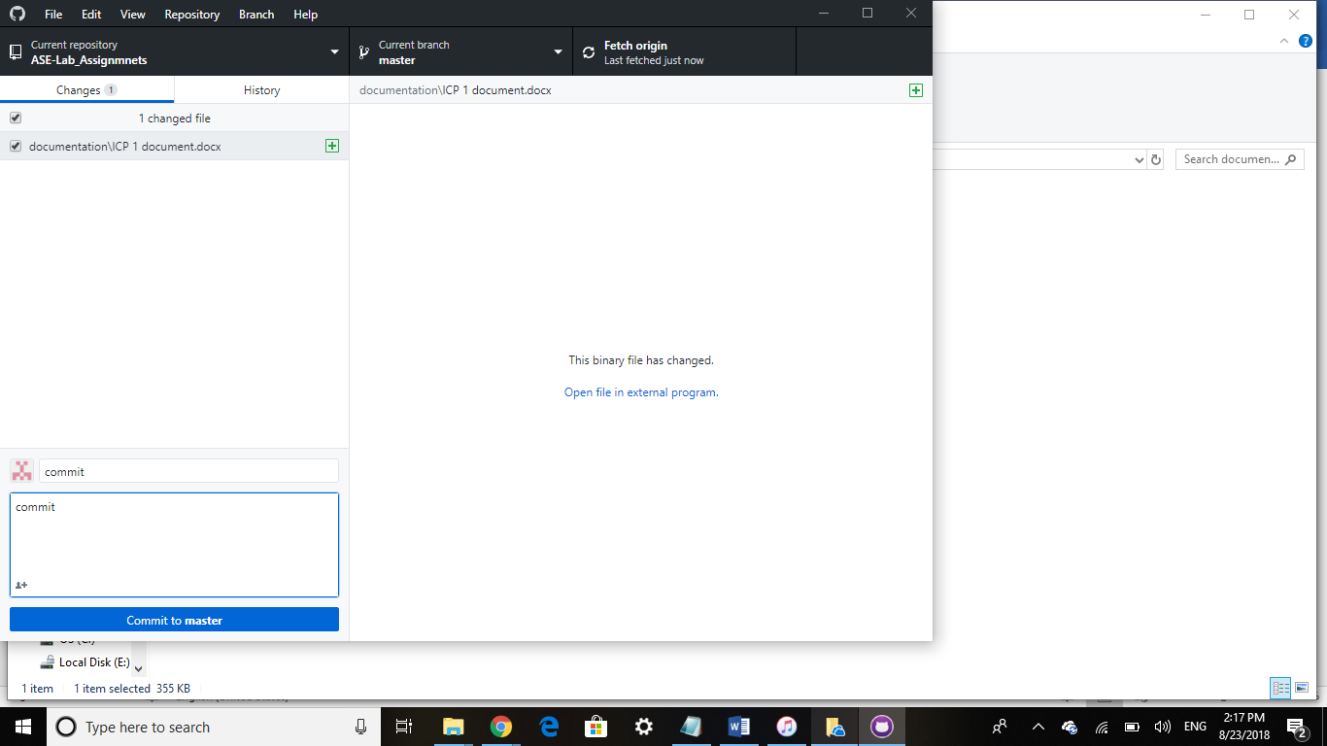

Cloning Repository using Gitbash:

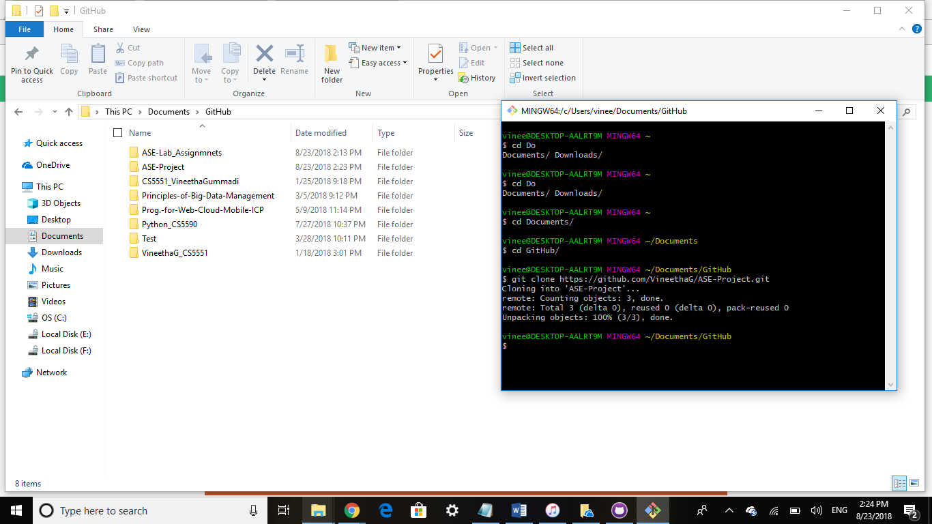

A screenshot of a cell phone

Description generated with very high confidence

**Zenhub:**

**A screenshot of a computer

Description generated with very high confidence**

**A screenshot of a computer

Description generated with very high confidence**

**Creately:**

**A screenshot of a social media post

Description generated with very high confidence**

**Webstrom:**

A screenshot of a social media post

Description generated with very high confidence

**Android Studio:**

**A screenshot of a social media post

Description generated with very high confidence**

**Brackets:**